**ITA0448 – STATISTICS WITH R PROGRAMMING FOR VECTORIZED EXPRESSIONS**

**SUBMITTED BY: DEVADARSHINI J REG NO: 192124092**

**DATE: 25/03/2023**

1. How to create the data frame and print it for the employee data set.

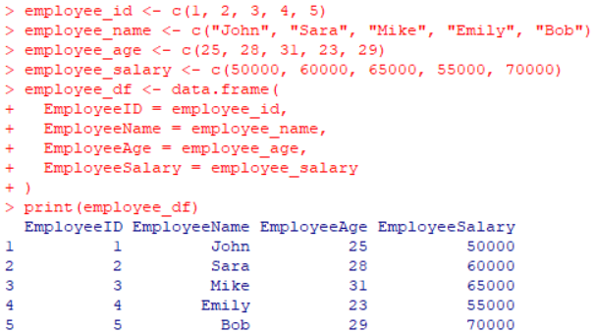

1. Write the code to get the Structure of the R Data Frame.

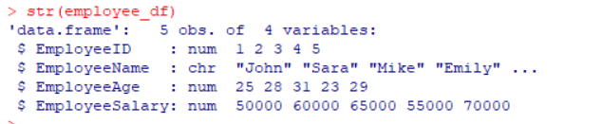

1. How to extract data from data frame for the above employee dataset.

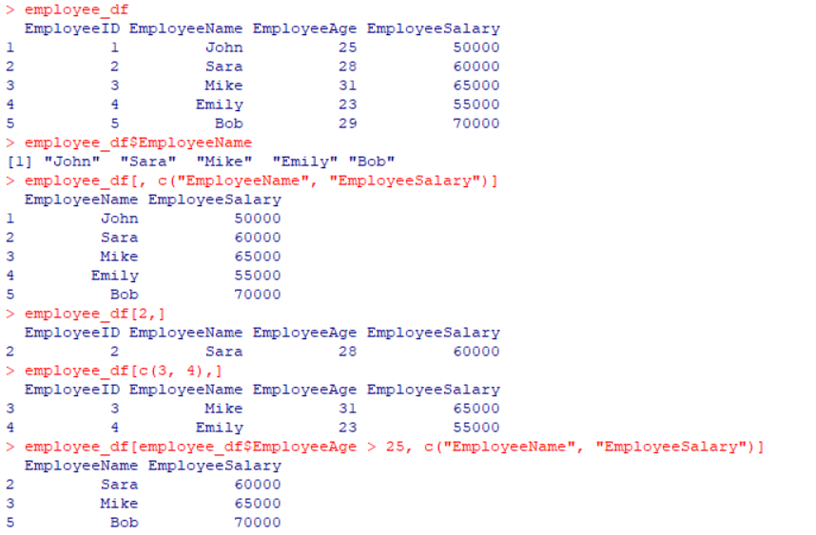

1. How to extract the first two rows and then all columns in employee data frame.

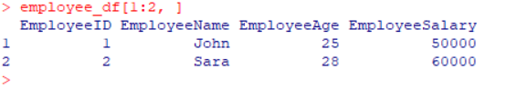

1. Write a code to extract 3 rd  and 5 th  row with 2 nd  and 4 th  column of the employee data.

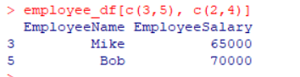

1. How to expand the data frame by adding rows and columns in data frame for employee data set.

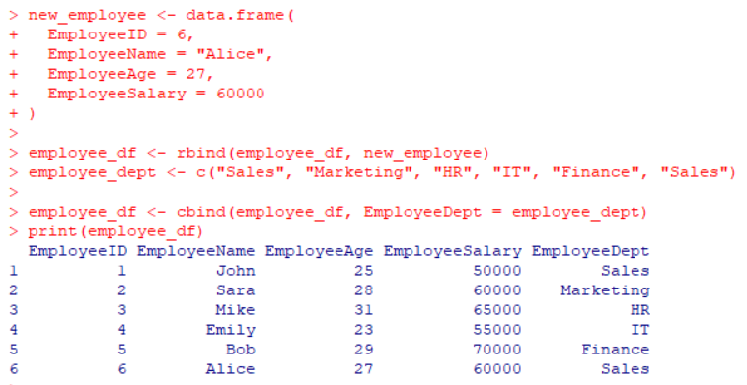

1. How to use the cbind() and rbind() in data frame for the fields city and zipcodedatas using vector and data frame.

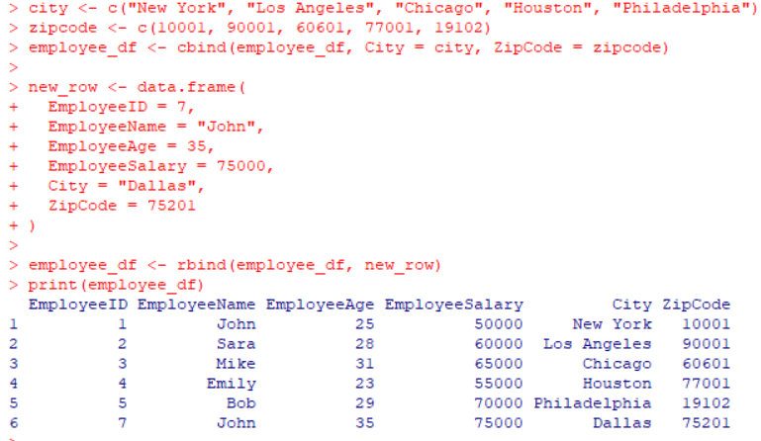

1. Create First Dataset with variables

* surname
* nationality

Create Second Dataset with variables

* surname
* movies

The common key variable is surname. How to merge both data and check if the imensionality is 7x3.

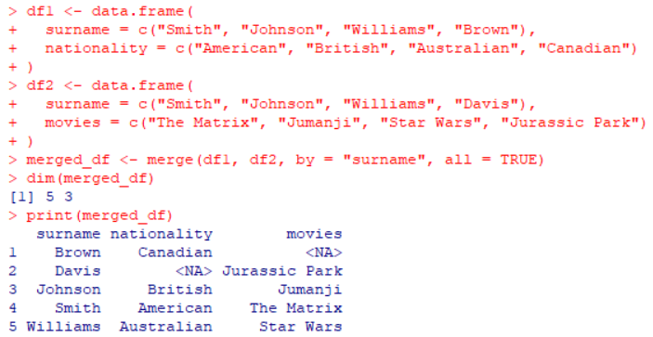

1. Write a R program to create an empty data frame.

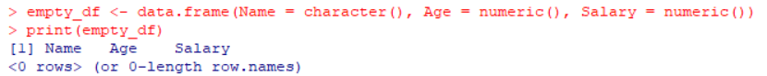

1. Write a R program to create a data frame from four given vectors

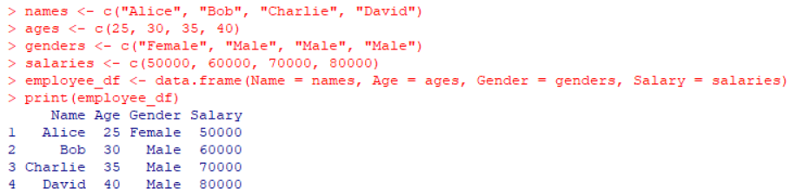

1. Write a R program to extract specific column from a data frame using column name.

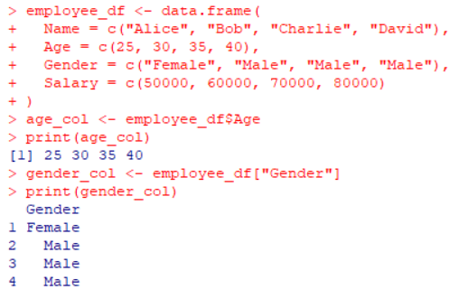

1. Write a R program to extract first two rows from a given data frame.

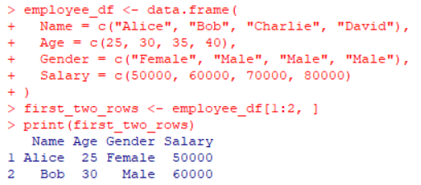

1. Write a R program to extract 3 rd  and 5 th  rows with 1 st  and 3 rd  columns from a given data frame.

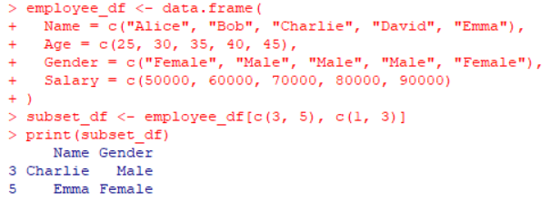

1. Write a R program to add a new coloumn to the dataframe.

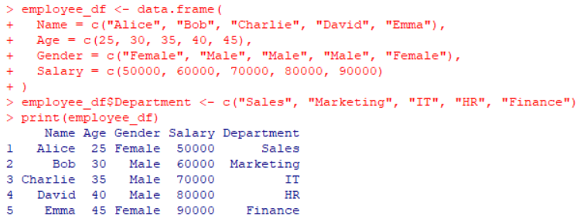

1. Write a R program to add new row(s) to an existing data frame.

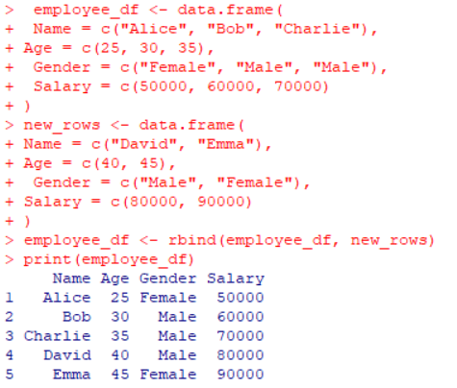

1. Write a R program to drop column(s) by name from a given data frame.

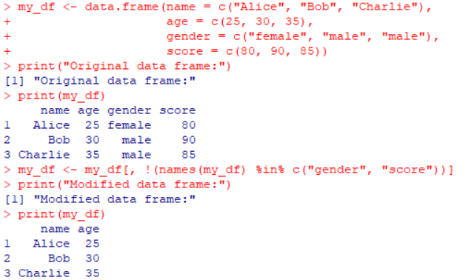

1. Write a R program to drop row(s) by number from a given data frame.

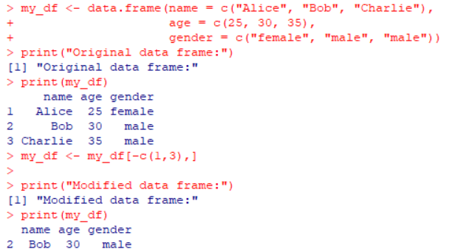

1. Write a R program to sort a given data frame by multiple column(s).

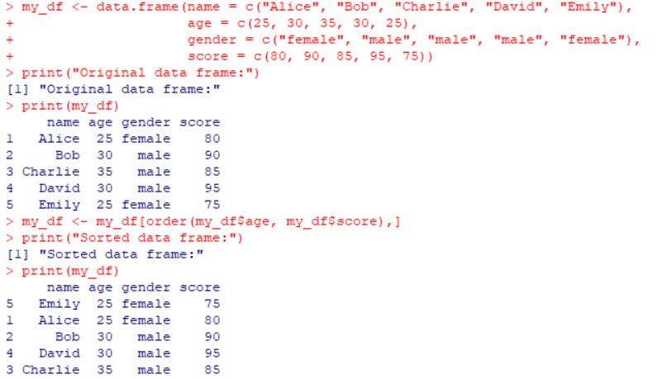

1. Write a R program to create inner, outer, left, right join(merge) from given two data frames.

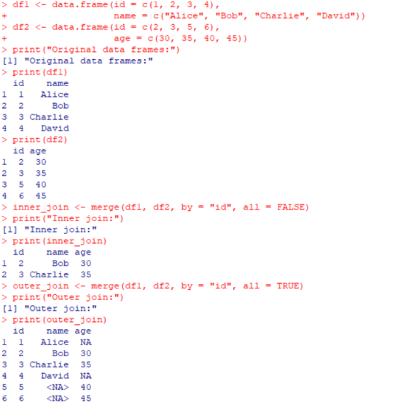 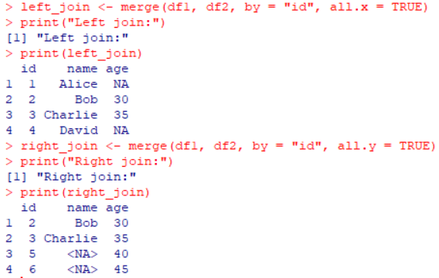

1. Write a R program to replace NA values with 3 in a given data frame.

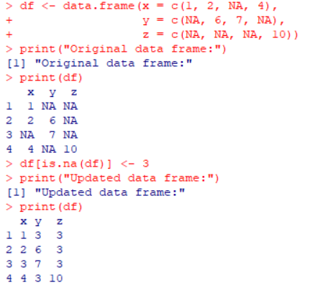

1. Write a R program to change a column name of a given data frame.

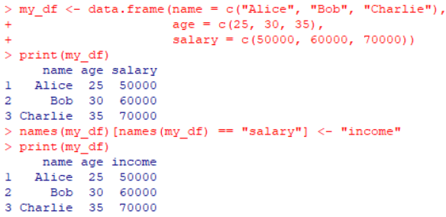

1. Write a R program to change more than one column name of a given data frame.

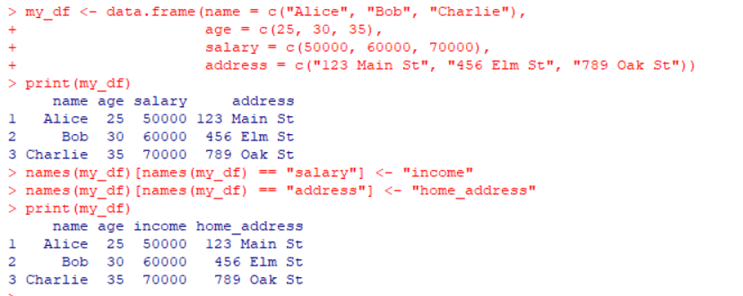

1. Write a R program to select some random rows from a given data frame.

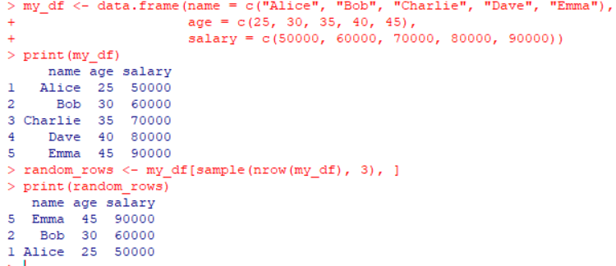

1. Write a R program to reorder an given data frame by column name.

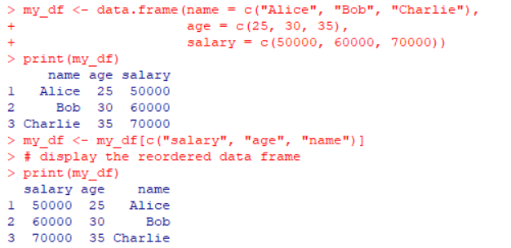

1. Write a R program to compare two data frames to find the elements in first data frame that are not present in second data frame.

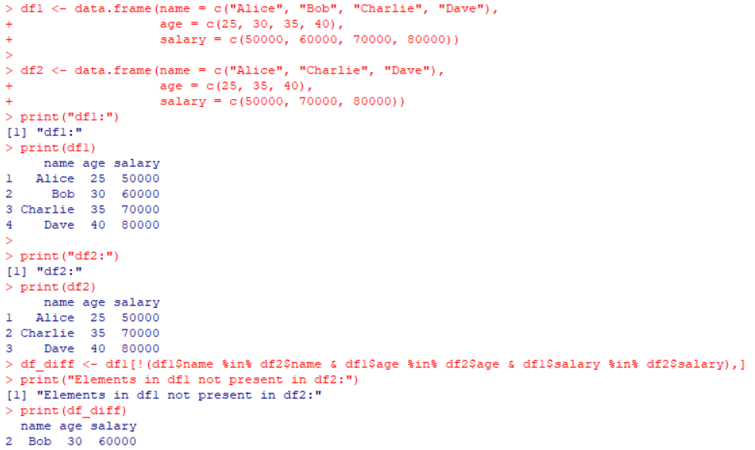

1. Write a R program to find elements which are present in two given data frames.

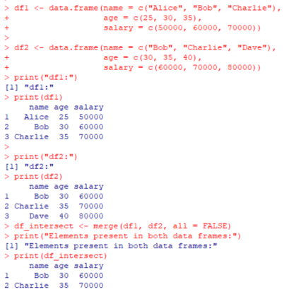

1. Write a R program to find elements come only once that are common to both given data frames.

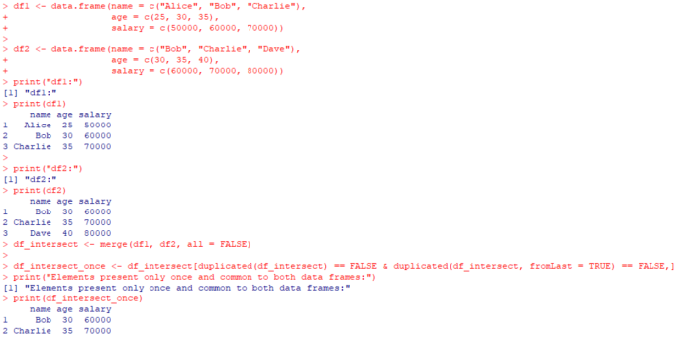

1. Write a R program to save the information of a data frame in a file and display the information of the file.

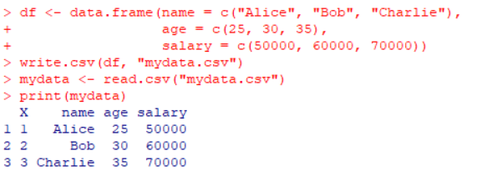

1. Write a R program to count the number of NA values in a data frame column.

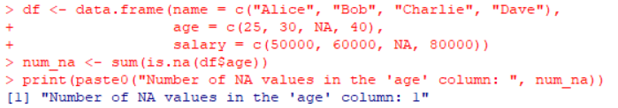

1. Write a R program to create a data frame using two given vectors and display the duplicated elements and unique rows of the said data frame.

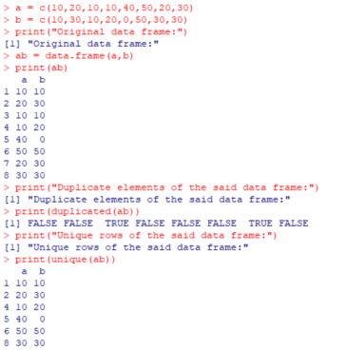

1. Write a R program to call the (built-in) dataset airquality. Check whether it is a data frame or not? Order the entire data frame by the first and second column.

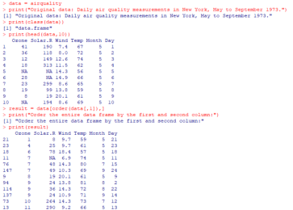

1. Write a R program to call the (built-in) dataset airquality. Remove the variables “Solar.R” and “Wind” and display the data frame.

